**Assignment : 01**

**Cloud Application And Development**

Arpita Kasaudhan

SAP ID : 500086690

Batch No : 03 CCVT (non hons)

OpenStack is an open source cloud computing platform which help users to create and manage virtual machines, networking, storage e.t.c. OpenStack is used for cloud computing and deployed as an Infrastructure as a service.

OpenStack components are :

**Nova** : this component provide compute services in openStack. Nova is responsible for managing the virtual machines in open stack . Compute is a controller that is used to manage resources in virtualized environments.

**Neutron**: This component provides network connectivity for instances. It allows users to create virtual networks, routers, and load balancers.

**Cinder**: This component provides block storage for instances, which allows users to create, attach, and detach volumes to instances.

**Glance**: This component provides image management service , allows users to create, store, and retrieve virtual machine images.

**Keystone**: This component provides authentication and authorization services which provide security and safety in OpenStack . It allow users to access the OpenStack API using their credentials.

**Horizon:** This is the first component that the user sees in the OpenStack . This component provides a web-based user interface for managing OpenStack resources.

**Swift**: This component provides object storage, which allows users to store and retrieve files in the cloud.

**Ceilometer**: This component in openStack is used for provides metering and monitoring services. The Ceilometer monitor the work and performance of components. It meter the usage and report it to OpenStack's individual users

**Heat:** This component provides orchestration services, allowing users to define and manage cloud infrastructure as code.

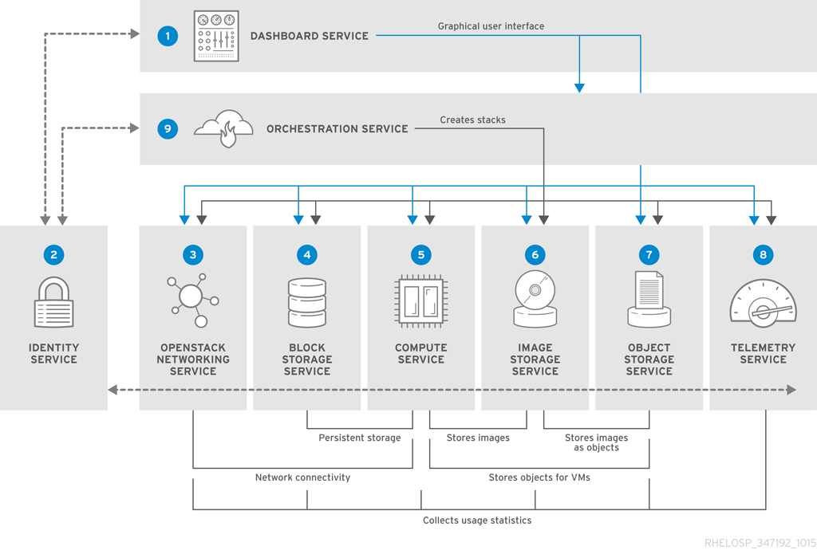

**OpenStack Architecture**

Top of Form